**William H. Weiskopf, IV**

william@weiskopf.me

720-663-9455

January 30, 2012

Darek Bruzgo

President

D&R CNC Machining, Inc.

dtbruzgo@gmail.com

Dear Darek:

After meeting with you last week, I am interested in your company both professionally, as a web designer, and personally, as a mechanical engineer. Since thinking over that which you have in mind for your new website, I am eager to get started with what I expect will be an enjoyable project.

This letter outlines the scope of the work you discussed with me, including objectives, procedures, benefits, and fees.

Objective

Design, prototype, and implement a website for your company, D&R CNC Machining. The prototype will be based on WordPress to allow for straightforward management of the site by your company. Implementation of the site may require finding and hiring a new host company in addition to implementing the website on the webhost’s servers. A possible additional project may include assessing and reconfiguring the company’s email system to allow for IMAP synchronization.

Procedure

1. Creation of a website design (estimated to take 2 weeks).
2. Creation of a prototype website on my servers for your company to demo (estimated to take 1.5 weeks).
3. Configuration of your webhost servers (hiring a new webhost and/or reconfiguring the email system may take place here as well) (estimated to take up to 1 week).
4. Implementation of the website on your webhost server (estimated to take up to 1.5 weeks).
5. Training and support

Note: Each of these steps will proceed following a meeting with you and after receiving your approval. If things are approved of quickly, the website will be complete six weeks from when you give me permission to start. I can start as soon as you notify me that you agree to this proposal.

Benefits

Following the implementation of this website, your company will have a fully functioning website that is straightforward to manage by you, the design of which is wholly according to your wishes. Benefits to your company include a website that represents the nature of your company to customers in an accessible manner and that respects your time by allowing you to make modifications to your sites content efficiently.

Fees

Design, prototyping, and implementation of the website will cost $220, due upon implementation of the website on your webhost’s server. If requested, searching for and setting up a new hosting company will cost an additional $25, not including the host’s costs, due upon successful host server setup. Reconfiguring the company’s email system would cost an additional $30, due on successful setup of the email system. Training and support for the new website will be discussed and agreed as we near implementation time of the new website.

Closing

I appreciate the opportunity to create a website for your company. If you accept this proposal, please sign a copy and return it to me.

Sincerely,

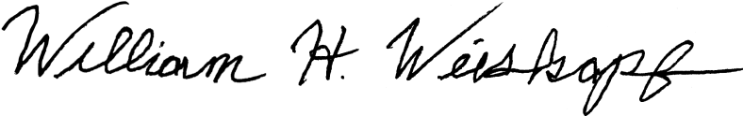**William H. Weiskopf, IV**

|  |  |  |
| --- | --- | --- |
| Response  By signing below, it is accepted that this contract sets forth the proposal for C&R Machining, Inc. | | |
|  |  |  |
| Accepted by: |  | Date: |